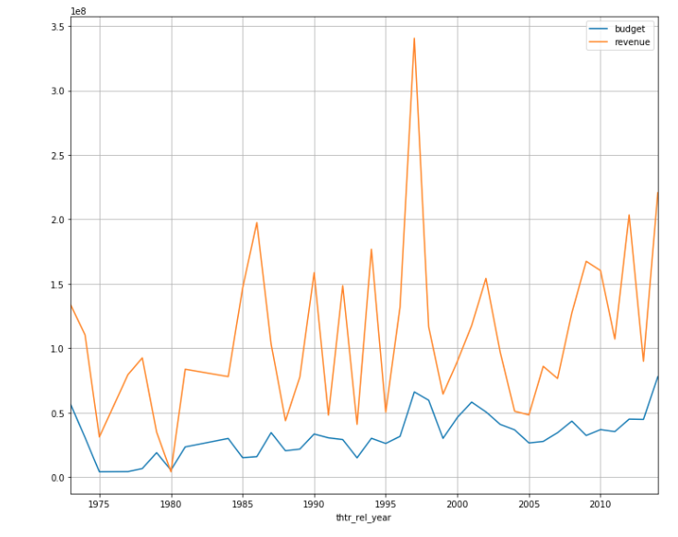**Distribution plot of budget and revenue**